TOPIC 1: INTRODUCTION

1.Given an array of strings words, return the first palindromic string in the array. If there is no such string, return an empty string "". A string is palindromic if it reads the same forward and backward.
Aim
To write a Python program to find and return the first palindromic string in a given array of strings. If no palindrome is found, r-eturn an empty string ("").
Algorithm
- Start.
- Read the list of strings.
- Traverse each string in the list.
- Check if the string is equal to its reverse.
- If it is a palindrome, return that string.
- If no palindrome is found after checking all strings, return an empty string ("").
- Stop.
Program
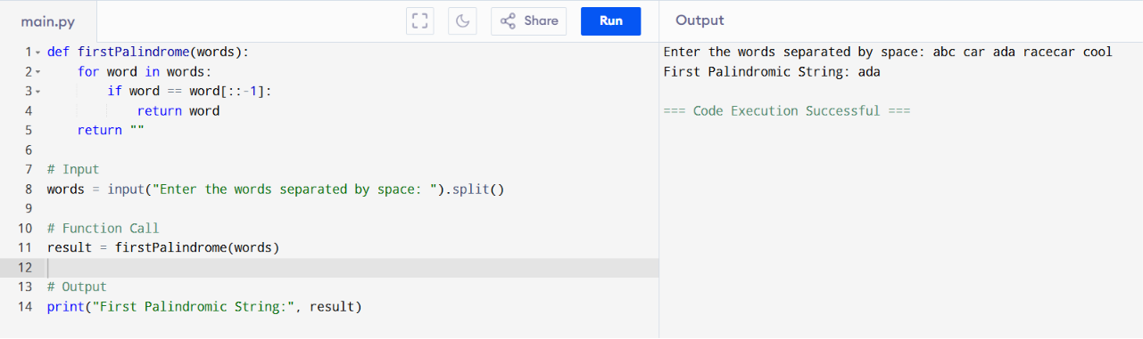
• Time Complexity: O(n²)
• Space Complexity: O(1)
2.You are given two integer arrays nums1 and nums2 of sizes n and m, respectively. Calculate the following values: answer1 : the number of indices i such that nums1[i] exists in nums2. answer2 : the number of indices i such that nums2[i] exists in nums1 Return [answer1,answer2].
Aim
To write a Python program to count:
- answer1: the number of elements in nums1 that also exist in nums2.
- answer2: the number of elements in nums2 that also exist in nums1.
Then return the result as [answer1, answer2].
Algorithm
- Start.
- Read the arrays nums1 and nums2.
- Convert both arrays into sets for faster searching.
- Initialize answer1 and answer2 to 0.
- Traverse each element in nums1.
  - If the element exists in nums2, increment answer1.
- Traverse each element in nums2.
  - If the element exists in nums1, increment answer2.
- Print the result as [answer1, answer2].
- Stop.

Program
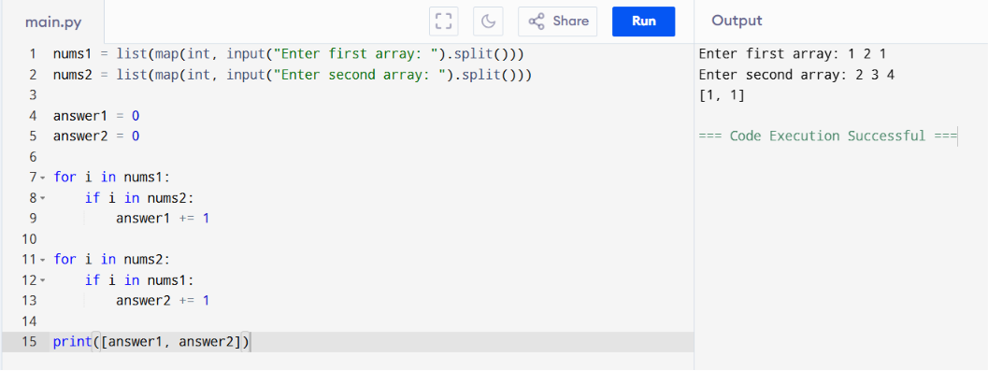
• Time Complexity: O(n²)
• Space Complexity: O(1)
3.You are given a 0-indexed integer array nums. The distinct count of a subarray of nums is defined as: Let nums[i..j] be a subarray of nums consisting of all the indices from i to j such that 0 <= i <= j < nums.length. Then the number of distinct values in nums[i..j] is called the distinct count of nums[i..j]. Return the sum of the squares of distinct counts of all subarrays of nums. A subarray is a contiguous non-empty sequence of elements within an array.
Aim
To write a Python program to find the sum of the squares of distinct counts of all subarrays of a given array.
Algorithm
- Start.
- Read the array nums.
- Generate all possible subarrays.
- Find the number of distinct elements in each subarray using a set.
- Square the distinct count and add it to the sum.
- Print the final sum.
- Stop.
Program
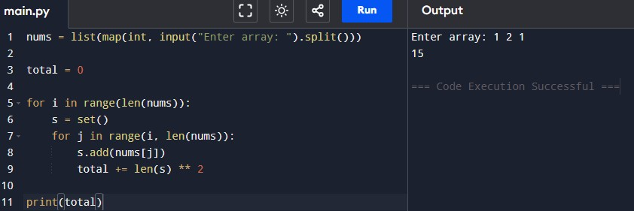

• Time Complexity: O(n²)
• Space Complexity: O(n)

4. Given a 0-indexed integer array nums of length n and an integer k, return the number of pairs (i, j) where 0 <= i < j < n, such that nums[i] == nums[j] and (i * j) is divisible by k.
AIM:
To count the number of pairs having equal values such that the product of their indices is divisible by k.
ALOGRITHM:
- Read the array and value of k.
- Traverse all pairs.
- Check whether the values are equal.
- Check whether index product is divisible by k.
- Count such pairs.
- Print the count.
PROGRAM AND INPUT/OUTPUT:
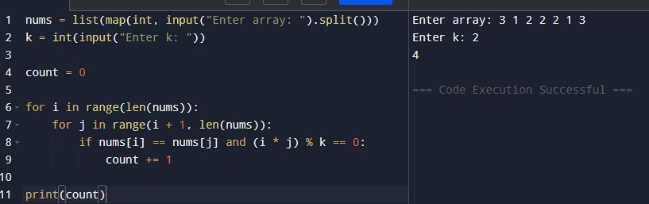
TIME COMPLEXITY: O(n²)
SPACE COMPLEXITY:O(1)
5. Write a program FOR THE BELOW TEST CASES with least time complexity Test Cases: -
Input: {1, 2, 3, 4, 5} Expected Output: 5
Input: {7, 7, 7, 7, 7} Expected Output: 7
Input: {-10, 2, 3, -4, 5} Expected Output: 5
AIM:
To find the maximum element in an array with minimum time complexity.
ALGORITHM:
- Read the array.
- Assume the first element is maximum.
- Compare each element with the current maximum.
- Update the maximum if a larger element is found.
- Print the maximum element.

PROGRAM AND INPUT/OUTPUT:
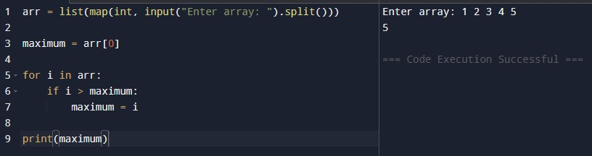
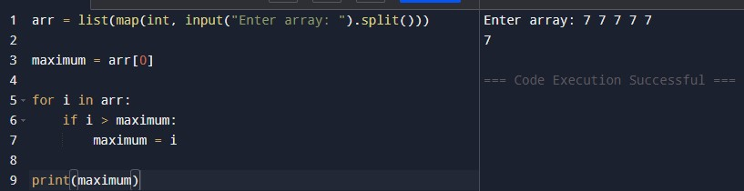

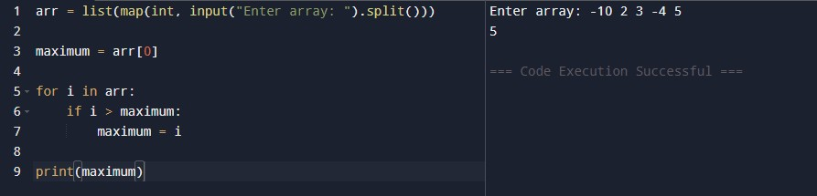

TIME COMPLEXITY: O(n²)
SPACECOMPLEXITY:O(1)
6. You have an algorithm that process a list of numbers. It firsts sorts the list using an efficient sorting algorithm and then finds the maximum element in sorted list. Write the code for the same.
AIM:
To sort a list using an efficient sorting algorithm and find the maximum element from the sorted list.
ALGORITHM:
- Read the list.
- If the list is empty, print an appropriate message.
- Otherwise, sort the list.
- Print the last element as the maximum.
PROGRAM:
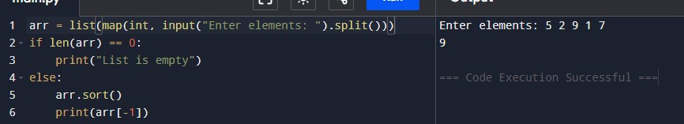
- Time Complexity : O(n log n)
- Space Complexity : O(1)
7.Write a program that takes an input list of n numbers and creates a new list containing only the unique elements from the original list. What is the space complexity of the algorithm?
AIM:
To create a new list containing only the unique elements from the given list.
ALGORITHM:
- Read the list.
- Create an empty list.
- Traverse the original list.
- If an element is not already present, add it to the new list.
- Print the new list.
PROGRAM:
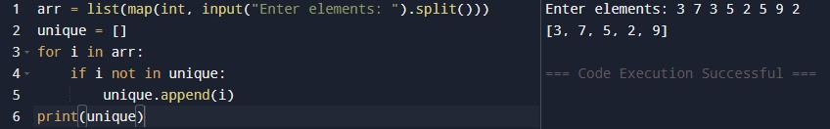
- Time Complexity : O(n²)
- Space Complexity : O(n)
8. Sort an array of integers using the bubble sort technique. Analyze its time complexity using Big-O notation. Write the code
AIM:
To sort an array of integers using the Bubble Sort technique.
ALGORITHM:
  - Read the array.
  - Compare adjacent elements.
  - Swap them if they are in the wrong order.
  - Repeat until the array is sorted.
  - Print the sorted array.
PROGRAM:
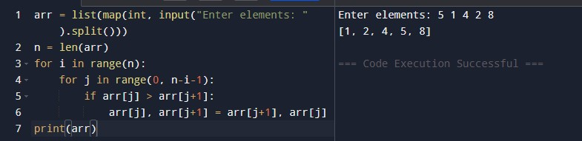
Time Complexity : O(n²)
Space Complexity : O(1)
9.Checks if a given number x exists in a sorted array arr using binary search. Analyze its time complexity using Big-O notation.
AIM:
To search for a given element in a sorted array using Binary Search.
ALGORITHM:
  - Read the array.
  - Sort the array.
  - Read the key.
  - Set low and high.
  - Find the middle element.
  - If found, print its position.
  - Otherwise, continue searching in the appropriate half.
  - If not found, print a message.
PROGRAM:
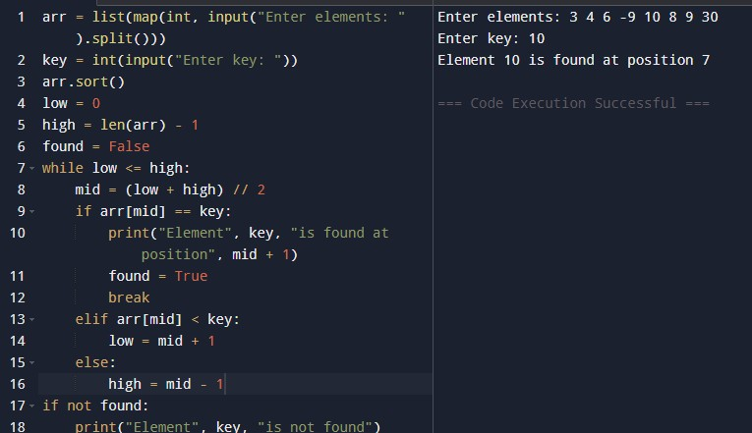
Time Complexity : O(n log n)
Space Complexity : O(1)
10.Given an array of integers nums, sort the array in ascending order and return it. You must solve the problem without using any built-in functions in O(nlog(n)) time complexity and with the smallest space complexity possible.
AIM:
To sort an array in ascending order using Merge Sort without using built-in sorting functions.
ALGORITHM:
  - Divide the array into two halves.
  - Recursively sort each half.
  - Merge the sorted halves.
  - Print the sorted array.
PROGRAM:
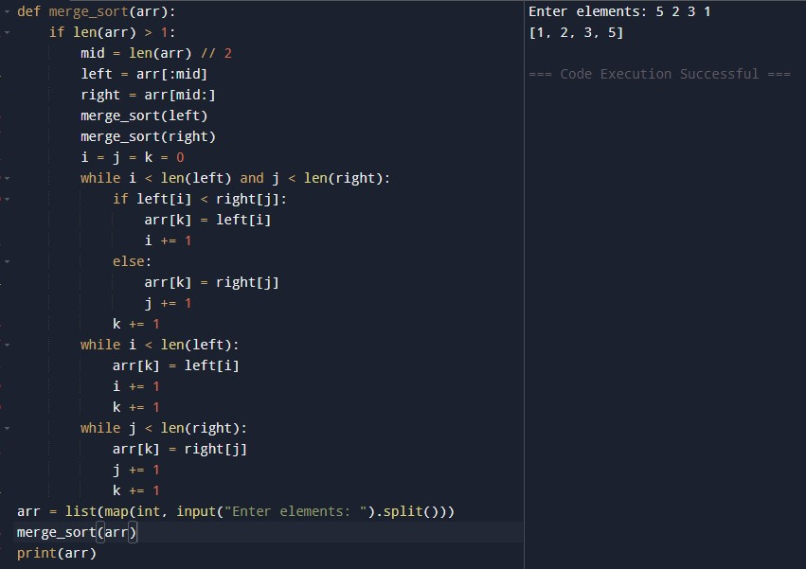
Time Complexity : O(n log n)
Space Complexity : O(n)

11.Given an m x n grid and a ball at a starting cell, find the number of ways to move the ball out of the grid boundary in exactly N steps.
AIM:
To find the number of ways to move the ball out of the grid boundary in exactly N steps.
ALGORITHM:
  - Read values of m, n, N, starting row and column.
  - Use recursion.
  - If the ball moves outside the grid, return 1.
  - If no steps are left, return 0.
  - Explore all four directions.
  - Return the total number of ways.
PROGRAM:
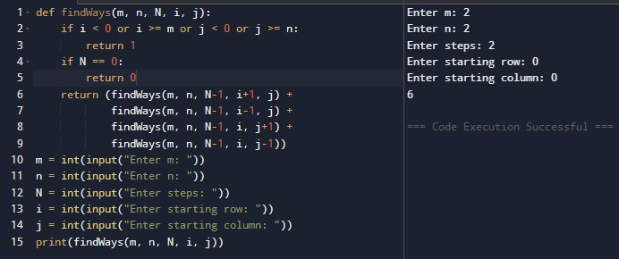
Time Complexity : _{O(4ᴺ)}
Space Complexity : O(N)

12.You are a professional robber planning to rob houses along a street. Each house has a certain amount of money stashed. All houses at this place are arranged in a circle. That means the first house is the neighbor of the last one. Meanwhile, adjacent houses have security systems connected, and it will automatically contact the police if two adjacent houses were broken into on the same night.
Examples:
Input : nums = [2, 3, 2]
Output : The maximum money you can rob without alerting the police is 3(robbing house 1).
AIM:
To find the maximum money that can be robbed from circularly arranged houses without robbing adjacent houses.
ALGORITHM:
  - If only one house exists, return its value.
  - Find maximum robbery excluding the last house.
  - Find maximum robbery excluding the first house.
  - Return the maximum of both.
PROGRAM:
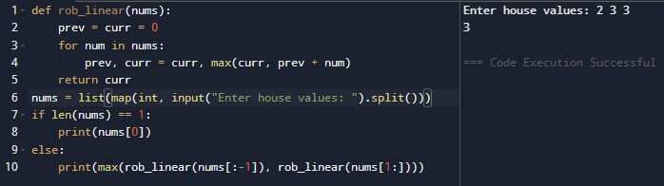
Time Complexity : O(n)
Space Complexity : O(1)
13.You are climbing a staircase. It takes n steps to reach the top. Each time you can either climb 1 or 2 steps. In how many distinct ways can you climb to the top?
Examples:
Input: n=4 Output:5 Input: n=3 Output:3
AIM:
To find the number of distinct ways to reach the top of a staircase.
ALGORITHM:
  - Read n.
  - If n ≤ 2, return n.
  - Use iteration to calculate Fibonacci sequence.
  - Print the total ways.
PROGRAM:
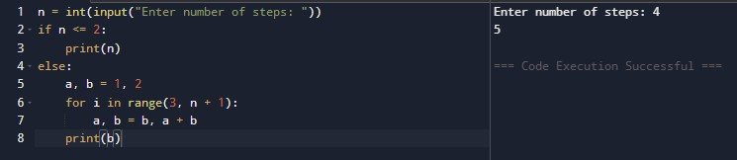
Time Complexity : O(n)
Space Complexity : O(1)

14.A robot is located at the top-left corner of a m×n grid .The robot can only move either down or right at any point in time. The robot is trying to reach the bottom-right corner of the grid. How many possible unique paths are there?
Examples:
Input: m=7,n=3 Output: 28
Input: m=3,n=2 Output: 3
AIM:
To find the number of unique paths from the top-left corner to the bottomright corner of a grid.
ALGORITHM:
  - Read m and n.
  - Create a DP array.
  - Initialize the first row and first column with 1.
  - Fill the remaining cells using:
dp[i][j] = dp[i-1][j] + dp[i][j-1]
  - Print the last cell.
PROGRAM:
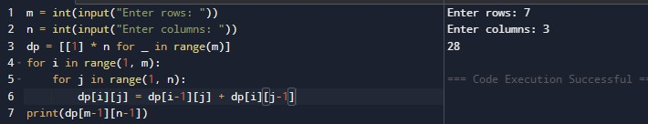

Time Complexity : O( n)
Space Complexity : O( n)

15.In a string S of lowercase letters, these letters form consecutive groups of the same character. For example, a string like s = "abbxxxxzyy" has the groups "a", "bb", "xxxx", "z", and "yy". A group is identified by an interval [start, end], where start and end denote the start and end indices (inclusive) of the group. In the above example, "xxxx" has the interval [3,6]. A group is considered large if it has 3 or more characters. Return the intervals of every large group sorted in increasing order by start index.
Example 1:
Input: s = "abbxxxxzzy"
Output: [[3,6]]
Explanation: "xxxx" is the only large group with start index 3 and end index
AIM:
To find all intervals of consecutive groups having three or more identical characters.
ALGORITHM:
  - Read the string.
  - Traverse the string.
  - Count consecutive identical characters.
  - If count ≥ 3, store the start and end indices.
  - Print all intervals.
PROGRAM:
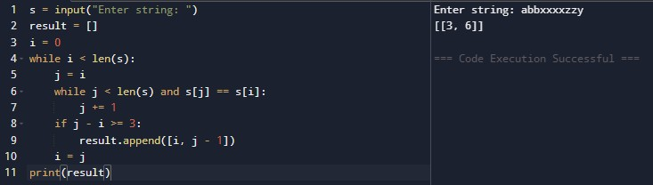

Time Complexity : O(n)
Space Complexity : O(k)

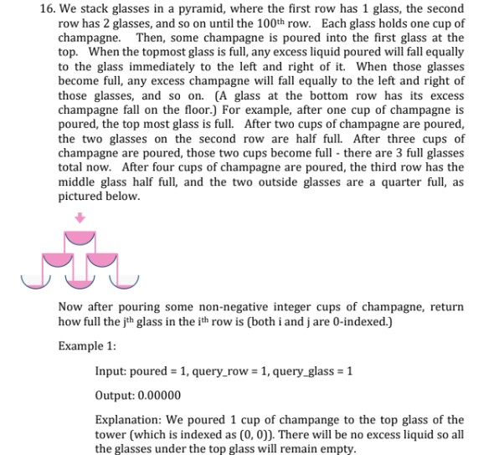
AIM:
To determine how full a particular glass is after pouring a given number of cups of champagne into the top glass of a champagne tower.
ALGORITHM:
  - Read poured, query_row, and query_glass.
  - Create a 2D array to represent the tower.
  - Pour all champagne into the top glass.
  - For each row:
  - If a glass has more than 1 cup, calculate the excess.
  - Split the excess equally between the two glasses below.
  - Print the amount in the required glass (maximum value is 1).
PROGRAM:
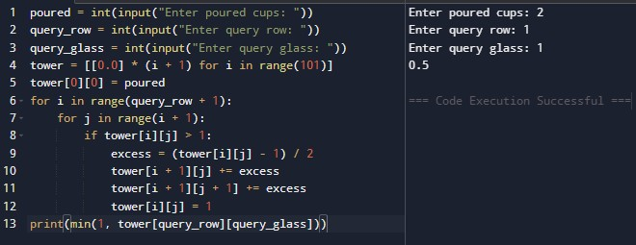

Time Complexity : O(n²)
Space Complexity : O(n²)

